Purpose
The Student Assessment Guide provides you with information on how the assessment for this unit will be conducted and the assessment evidence you will need to provide that demonstrates your competency in the unit.

1. Unit and VET Lecturer Details

Unit Code | ICTWEB302 & ICTICT301
Unit Title | Build simple websites using commercial programs & Create user documentation
VET Lecturer Name
Location
Phone
Email
Application | ICTWEB302:  This unit describes the skills and knowledge required to use web authoring tools to create, modify and test, simple web pages and websites.  It applies to individuals with responsibility for creating and maintaining simple websites.  No licensing, legislative or certification requirements apply to this unit at the time of publication.  ICTICT301:  This unit describes the skills and knowledge required to create user documentation that is clear to the target audience and easy to navigate.  It applies to individuals who may work under supervision with responsibility to support others in a range of information and communications technology (ICT) areas.  No licensing, legislative or certification requirements apply to this unit at the time of publication.

2. Assessment Information

This unit is normally delivered as a cluster called WEBDEV0. This cluster includes ICTICT301 and ICTWEB302 and the student resources are found at https://webdev0.brambling.cdu.edu.au/. Since this in an integrated unit the student assessment Guides for the two units are identical.

Students need only submit once for WEBDEV0 and the lecturer will record the assessment against the relevant units.

Disclaimer
Charles Darwin University is collecting information for the purpose of assessing students. Only CDU authorised staff have access to this information. If required for audit purposes, your details may be forwarded to officers from Australian Skills Quality Authority, Australian Government’s national regulator for the vocational education and training sector or other technical experts/advisors. If you are an apprentice/trainee, your personal information, attendance details, progress and results will be disclosed to your employer. If you are under the age of 18 years your personal information, attendance details and results may be disclosed to your parent/guardian. Your personal information will not be disclosed to any other third party without your consent, unless authorised or required by law.

 |  | Observation Checklist Assessment
Assessment Task Number: 1 Part A
Student Name: |  |  |  | Student Number:
VET Lecturer/Assessor Name:
Unit Code: ICTWEB302 & ICTICT301 |  | Unit Title: Build simple websites using commercial programs & Create user documentation
Due Date: End of Session 1 |  | Date Observed: All Sessions |  | Number of attempts allowed: 2
The observation was conducted at:
Instructions to Student
To successfully demonstrate competency, you must:

Complete the observation checklist in class in the first session and hand in to your lecturer

This assessment will be commenced by the student in the first session and then completed by the lecturer at the end of the course based on observation during class.

Reasonable Adjustment
The assessor must record any adjustment made available to the student for this assessment– e.g. written assessment given orally, time extensions, etc.

Evidence Observed
Did the Student: |  |  | Comments |  | Y | N
1. | Understands ACS Code of ethics, OHS on computer and sustainability issues
2. | Able to use web authoring tool (Notepad, Dreamweaver, Netbeans etc)
3. | Able to transfer site to the web server using a tool (Cpanel, Dreamweaver, Filezilla)
4. | Able to create web page files
5. | Able to work between various file eg html file and css file pointing to the same page
6. | Uses the tools available in the web authoring tool
7. | Saves files to appropriate filing structure for a web page
8. | Uploads files to a web server
9. | Determine documentation standards
10. | Produce user documents
11. | Review and sign off documents

Assessor Feedback: Attempt number 1 ☐ 2 ☐ 3 ☐ Successful ☐ Not Successful ☐
Assessor Signature: Date:

I have received feedback on my performance:

Student Signature: Date:

 | Project Assessment
Assessment Task Number: 1 Part B
Student Name: |  |  | Student Number:
VET Lecturer/Assessor Name:
Unit Code: ICTWEB302 & ICTICT301 |  | Unit Title: Build simple websites using commercial programs & Create user documentation
Due Date: End of Session 6 |  | Date Submitted: | Number of attempts allowed: 2
Instructions to Student
This assessment must be submitted through the ict.submit@cdu.edu.au email in the normal manner. The only information that you need to include in the assessment is the url to your website.

To successfully demonstrate competency you must:
- Submit a website for marking which is currently live on the internet
- The web site must have three pages as outlined in the instructions
- HTML validates using W3c Validator
- Site works in Chrome, Firefox and on mobile devices
- Navigation is accurate and consistent across the pages
- Form should work if provided with action address, method should be post
- Accessibility to conform with legal standard
A client has come to you to develop a three page web site. The client has a rough guide to how the pages should look and the following requirements. The client has provided you with some pictures and text in a zipped folder.

- This should be bright and colourful.
- You could also use the pictures provided as background images or as a slide show on this page.
- At this stage we are only looking at the look and feel of the page. We have engaged a web database company to develop our database and they will provide all the active connections to this page at a later date.
- The navigation bar at the top should be interesting, we would like to see images used as part of the navigation bar.
- We would prefer that the footer stays at the bottom of the page and does not scroll.
- This site must work on the latest Chrome, Internet Explorer, Fire Fox, Opera and Safari browsers on a desktop as well as on the standard browsers in IOS (Iphone and Ipad) and Android devices. We want the site on the Internet so we can see it the same way that our customers will.
- The blurbs in the coffee page should match the pictures, we may add more blurbs and pictures.
- The blurbs and pictures are currently being provided by us but in the future we intend to get them off a database maintained by our web database company. You need to set the page up.
- The login page just needs to be created. We have employed a web company to handle the database and they will provide the site details at a later date.
- This form should not work yet, we just want to see how it will look.
You must also conduct a small sample usability survey on the site and present the results with the technical documents.

This is a rough design of the three pages:

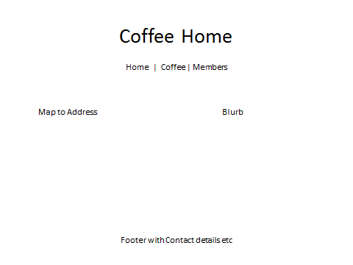

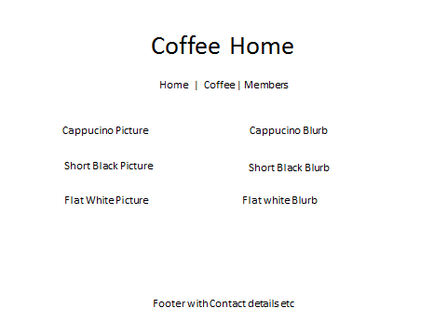
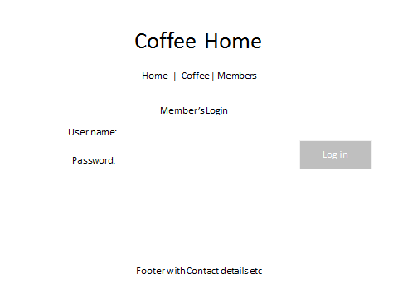
Reasonable Adjustment
The assessor must record any adjustment made available to the student for this assessment– e.g. written assessment given orally, time extensions, etc.

Student Declaration
I declare that no part of this assessment/assignment has been copied from any other person's work, except where due acknowledgment is made in the text, and no part of this assessment/assignment has been written for me by any other person except where such collaboration has been authorised by the assessor concerned.

Student Signature: Date:

Items to Submit |  | Requirements | S | U
1. | Web site URL

Assessor Feedback: Attempt number 1 ☐ 2 ☐ 3 ☐ Successful ☐ Not Successful ☐
Assessor Signature: Date:

I have received feedback on my performance:

Student Signature: Date:

 |  |  | Project Assessment
Assessment Task Number: 1 Part c
Student Name: |  |  |  |  |  | Student Number:
VET Lecturer/Assessor Name:
Unit Code: ICTWEB302 & ICTICT301 |  |  |  | Unit Title: Build simple websites using commercial programs & Create user documentation
Due Date: End of Session 7 |  |  |  | Date Submitted: |  | Number of attempts allowed: 2
Instructions to Student
This assessment must be submitted through the ict.submit@cdu.edu.au email in the normal manner. The only information that you need to include in the assessment is a document containing the Style Guide relevant to your site. This document should be in Word type format similar to the template and sample found on https://webdev0.brambling.cdu.edu.au/.

To successfully demonstrate competency you must:
- Style Guide Template completed with information relevant to own site
- Site map of at least one design (Document, xml, etc)
- Accessibility information provide to legal standard
- Usage survey completed and analysed.

Style Guide Template

Goal of Site

This is a clear vision of what the site is trying to do which should be as short as possible

Text:

Font size, spacing, typeface, type of list (numbered or bullet), use of full stops (single or double spacing) heading usage) etc

Colours:

Background, font, banners, etc

Images

Use of logos, style of images, use of icons, etc

Layout:

Basic shape, size of blocks, use of gutters, layout features eg rounded corners etc

Copy Guide

Tone of voice, writing style (formal, informal, authoritative etc)
Intended audience

Web Guide

Use and action of buttons, hyperlinks and hover feature etc
Navigation features, location and action, etc
Simple coding conventions: type of naming for classes and ids, Javascript integration etc
Site organisations: directory structure, site map, etc
HTML standards: doctype, validation, closing tags convention used etc
Site Infrastructure
Search Engine Optimisation techniques employed etc
Accessibility: accessibility techniques used to ensure the site complies with legal requirements.
Usability: testing methods, feedback analysed, etc

Reasonable Adjustment
The assessor must record any adjustment made available to the student for this assessment– e.g. written assessment given orally, time extensions, etc.

Student Declaration
I declare that no part of this assessment/assignment has been copied from any other person's work, except where due acknowledgment is made in the text, and no part of this assessment/assignment has been written for me by any other person except where such collaboration has been authorised by the assessor concerned.

Student Signature: Date:

 | Items to Submit |  |  |  | Requirements |  | S | U
 | 1. | Style Guide submitted
Assessor Feedback: Attempt number 1 ☐ 2 ☐ 3 ☐ Successful ☐ Not Successful ☐
Assessor Signature: Date:

I have received feedback on my performance:

Student Signature: Date:

